ADVANCED FUEL CYCLE SCENARIO STUDY IN THE EUROPEAN CONTEXT BY USING DIFFERENT BURNER REACTOR CONCEPTS

V. Romanello¹, C. Sommer², M. Salvatores¹, W. Stacey², W. Maschek¹, B. Petrovic², F. Gabrielli¹, A. Schwenk-Ferrero¹, A. Rineiski¹, B. Vezzoni¹

¹KIT (Karlsruhe Institute of Technology) – IKET (Institute for Nuclear and Energy Technologies) – B421, Hermann-Von-Helmholtz-Platz 1, 76344 Eggenstein-Leopoldshafen, Germany
²NRE Program, Georgia Institute of Technology, Atlanta, GA, USA 30332-0745

Abstract

Different types of fast spectrum dedicated burners have been proposed for the management of radioactive wastes in the frame of various advanced fuel cycle scenarios. Accelerator Driven Systems (ADS) and critical low conversion ratio fast reactors have been studied, e.g. within the European context. A potential alternative system is a fusion-fission hybrid (FFH). In the present study, the SABR (Sub-critical Advanced Burner Reactor) system has been considered, a sodium cooled fast reactor driven by a D-T fusion neutron source. In order to intercompare the different systems, a systematic study is underway. The performances of the two types of systems (SABR, ADS) will be compared from a minor actinides (MA) or transuranics (i.e. Pu+MA) burning potential point of view. The present paper reports preliminary results of the first phase of such study, i.e. the comparison of SABR and of an ADS when used as minor actinides burners.

Introduction

According to some analysts predictions, we witness today to a renewed interest in nuclear energy production. At present according to IAEA [1] 441 nuclear reactors are in operation (with a total power of ca. 375 GWe) and 60 more are under construction. Nuclear waste management still represents a major source of concern in public opinion [2], and Partitioning and Transmutation (P&T) strategies, aiming at the reduction of the burden on the geological disposal (see, among many others, [3], [4], [5], [6], [7]) have been considered. P&T technologies, by separating and transmuting long lived transuranic elements contained in the spent fuel, can help to reduce the radiotoxicity of the wastes and should allow in principle also the reduction of the residual heat in a permanent geological repository, with a potential beneficial impact on the repository size and characteristics.
In the present paper we investigated, within a collaboration between the GA-Tech (USA) and KIT (Germany), the comparison between the ADS-EFIT (Accelerator Driven System – European Facility for Industrial Transmutation) and SABR (Subcritical Advanced Burner Reactor) in a so-called ‘double strata’ strategy developed in order to manage Spent Fuel (SF) inventories of European countries. The main objective of this scenario has been the total waste minimization, in a politically heterogeneous region with nation-specific nuclear energy policies. Similar studies have been performed in the past based on the use of ADS-EFIT as a transmuter ([8], [9], [10]). Both ADS-EFIT and SABR offer great flexibility with respect to the choice of fuels and could, in principle, lighten the spent fuel disposal issues also in case of a future transition toward innovative energy production technologies and to manage the intergenerational liabilities.
The SABR fusion-fission hybrid concept is a sodium cooled sub-critical fast reactor driven by a D-T fusion neutron source. The fusion neutron source based on ITER physics and technology and has a maximum source strength of 500 MW_{th}. Operating both SABR and ADS-EFIT sub-critically allows to load them with a 100% transuranic (TRU) fuel, thus increasing the amount of TRU that can be burned in the reactor, and consequently maximizing the number of LWRs supported by a single burner reactor. The fuel residence time in SABR is limited by the radiation damage of the cladding - not criticality - resulting in a greater single pass burning performance. A longer residence time increases fuel burn up and facilitates reprocessing. The performances of the two types of systems (FFH and ADS) will be compared when burning minor actinides (MA) or TRU (i.e. Pu+MA). The present paper reports preliminary results of the first phase of such study, i.e. the comparison of SABR and of an ADS-EFIT when used as MA burners. In practice, the performance of the two burner systems is investigated in a so-called double strata fuel cycle within a European scenario by means of COSI6 code simulations. In the scenario two groups of nations are taken into consideration: the first one with a stagnant or phasing-out nuclear policy, the second with an ongoing nuclear power development. While the objective of the first group of countries is to reduce as much as possible the TRU legacy inventories by the end of the century, the objective of the second group of countries is to reprocess the spent fuel in order to recover Pu for successive use in fast reactors (FR), to reduce and successively stabilize the MA inventory, and to avoid their build-up, that can jeopardize the future deployment of fast reactors. In the scenario study both groups of countries avoid the deployment of fuel cycle facilities in isolation, but they are deploying in common a regional set of plants; regional strategies can provide in fact a framework for the implementation of innovative fuel cycle strategies with an appropriate share of efforts and facilities among different countries. The chosen scenario has already been investigated in the frame both of, an EU project and of a NEA/OECD Expert Group [8], using ADS-EFIT to burn MA. In the present paper the fuel cycle scenario is analyzed in terms of the required number of SABR systems to be deployed, fuel fabrication and reprocessing facilities and of the impact on some geological repository characteristics. On the basis of the European scenario the performance of the SABR system is compared to that of the ADS-EFIT. In order to avoid ambiguities as much as possible , the initial spent fuel inventories and other fuel cycle parameters are taken to be the same when using the two different burner reactors.

Fast system core design used for the comparison and main results of the core neutronics assessment
In order to assess the performance of fast critical MA burner cores in the scenario analysis, both ADS-EFIT and SABR cores were simulated by the ERANOS code system [11] using the JEF 2.2 nuclear data library [12]. Both cores were loaded with the same fuel type and composition: an MgO-(TRU)O₂ fuel having, respectively, a minor actinide-to-Pu ratio MA/Pu ~1.2 with isotopic composition coming from a mixture of LWR spent fuels i.e. 90% of UOX cooled 30 years and 10% of MOX cooled 15 years, both with burn up 45GWd/tHM, (for the isotopic composition see Table 1). The MA/Pu ratio ~1.2 is representative of TRU fuels proposed for use in ADS-EFIT [13, 14] and is mainly related to the requirement of keeping the reactivity loss during the cycle fairly constant.
SABR [15] is a 3000 MW_{th} sodium cooled subcritical fast reactor designed to burn the TRU from spent nuclear fuel. The fusion neutron source is surrounded on the outside by an annular fission core. The fusion neutron source in SABR is based on ITER physics and capable of producing up to ~500 MW of thermal power, 1.76·10²⁰ neutrons per second [16]. The annular fission core is arranged in four annular rings of fuel assemblies to facilitate a 4-batch fuel cycle with a cycle time of 700 days resulting in a fuel residence time of 2800 days, with a quarter of the fuel being removed and replaced with fresh fuel after each cycle. SABR is capable of transmuting up to 1.06 tonnes of TRU per full power year.
The fusion power necessary for this system to maintain 3000 MW_{th} varies between 195 MW and 325 MW at BOC and EOC respectively, and is 515 MW at beginning of fuel life (BOL).
As indicated above, the strategy adopted for the ADS-EFIT is quite different, i.e. the proton beam power is kept relatively constant between BOC and EOC.
The layout of the ADS-EFIT can be found in [14, 17]. The main core parameters of SABR and of the subcritical ADS-EFIT are summarized in Table 2. The respective neutronic characteristics of SABR and of the ADS-EFIT core were investigated accounting for the different coolants (respectively Na and Pb). The performance differences can be put in evidence by analysing the core neutron spectra and the spectrum indexes. As an example, we show in Fig. 1 the comparison between the multi-group core average neutron spectra of ADS-EFIT and of the SABR. The energy spectrum differences are partly (i.e. >1MeV) given by the different spectrum of the external neutron source and partly (i.e. <1 MeV) by the different coolants nature, respectively, Pb and Na, and their different volume fractions (which is 63% in ADS-EFIT, and 51% in SABR). At low energy the comparison of the two neutron spectra indicates the effect on the SABR spectrum of the main Na-23 resonance (at ~2.85 keV), while the ADS-EFIT low energy spectrum is determined by the neutron slowing down in lead; the Mg-24 elastic scattering resonances at 19.6 keV and 83.4 keV are evident for both spectra. In particular, the two energy spectra cross each other at ~2-3 keV.
As for multigroup cross sections, in Fig. 2 Pu-239 and Am-241 capture cross sections vs. energy (in 33 energy groups) are shown for ADS-EFIT and SABR: their differences are relatively small.
Some ADS-EFIT and SABR spectrum indexes at the BOL and at the end of fuel life (EOL) are compared in Table 3. The values confirm, e.g., the effect of the softer spectrum of ADS-EFIT at high energy that translates e.g. in a lower Pu-238 fission to Pu-239 fission rate ratio.
The results of the core composition evolution during irradiation show that the specific consumption rates (referred to thermal energy produced) are very similar, as expected (Table 4). To go into detail, the results of Table 4 show that both types of cores can burn a significant amount of Am (however, a slightly lower amount is burned by SABR per terawatt-hour-thermal because of the harder spectrum), but Cm is still building up in both cases (even if, for the average fuel residence time, the build-up is less pronounced in SABR). As for Pu, the total balance is close to zero in both cases. This is essentially due to the burn-out of Pu-239 and the build-up of Pu-238. The Pu-238 build-up has several components, but it is mostly associated to the consumption of Am-241 due to neutron captures and successive α-decay of Cm-242. As a consequence, Pu-238 build-up increases with increasing Am-241 consumption. On the other side the softer ADS-EFIT spectrum causes a higher Am-241 capture reaction with respect to SABR, as testified also by the higher amount of Am-242m production (Table 4). Also the Am-241 fission to Pu-239 capture cross sections ratio (Table 3) is higher in SABR at BOL, but this trend is inverted at EOL.
In summary, these results confirm that both core types are suitable for MA legacy reduction.
Fig. 1. SABR and ADS-EFIT spectra comparison (at BOL)
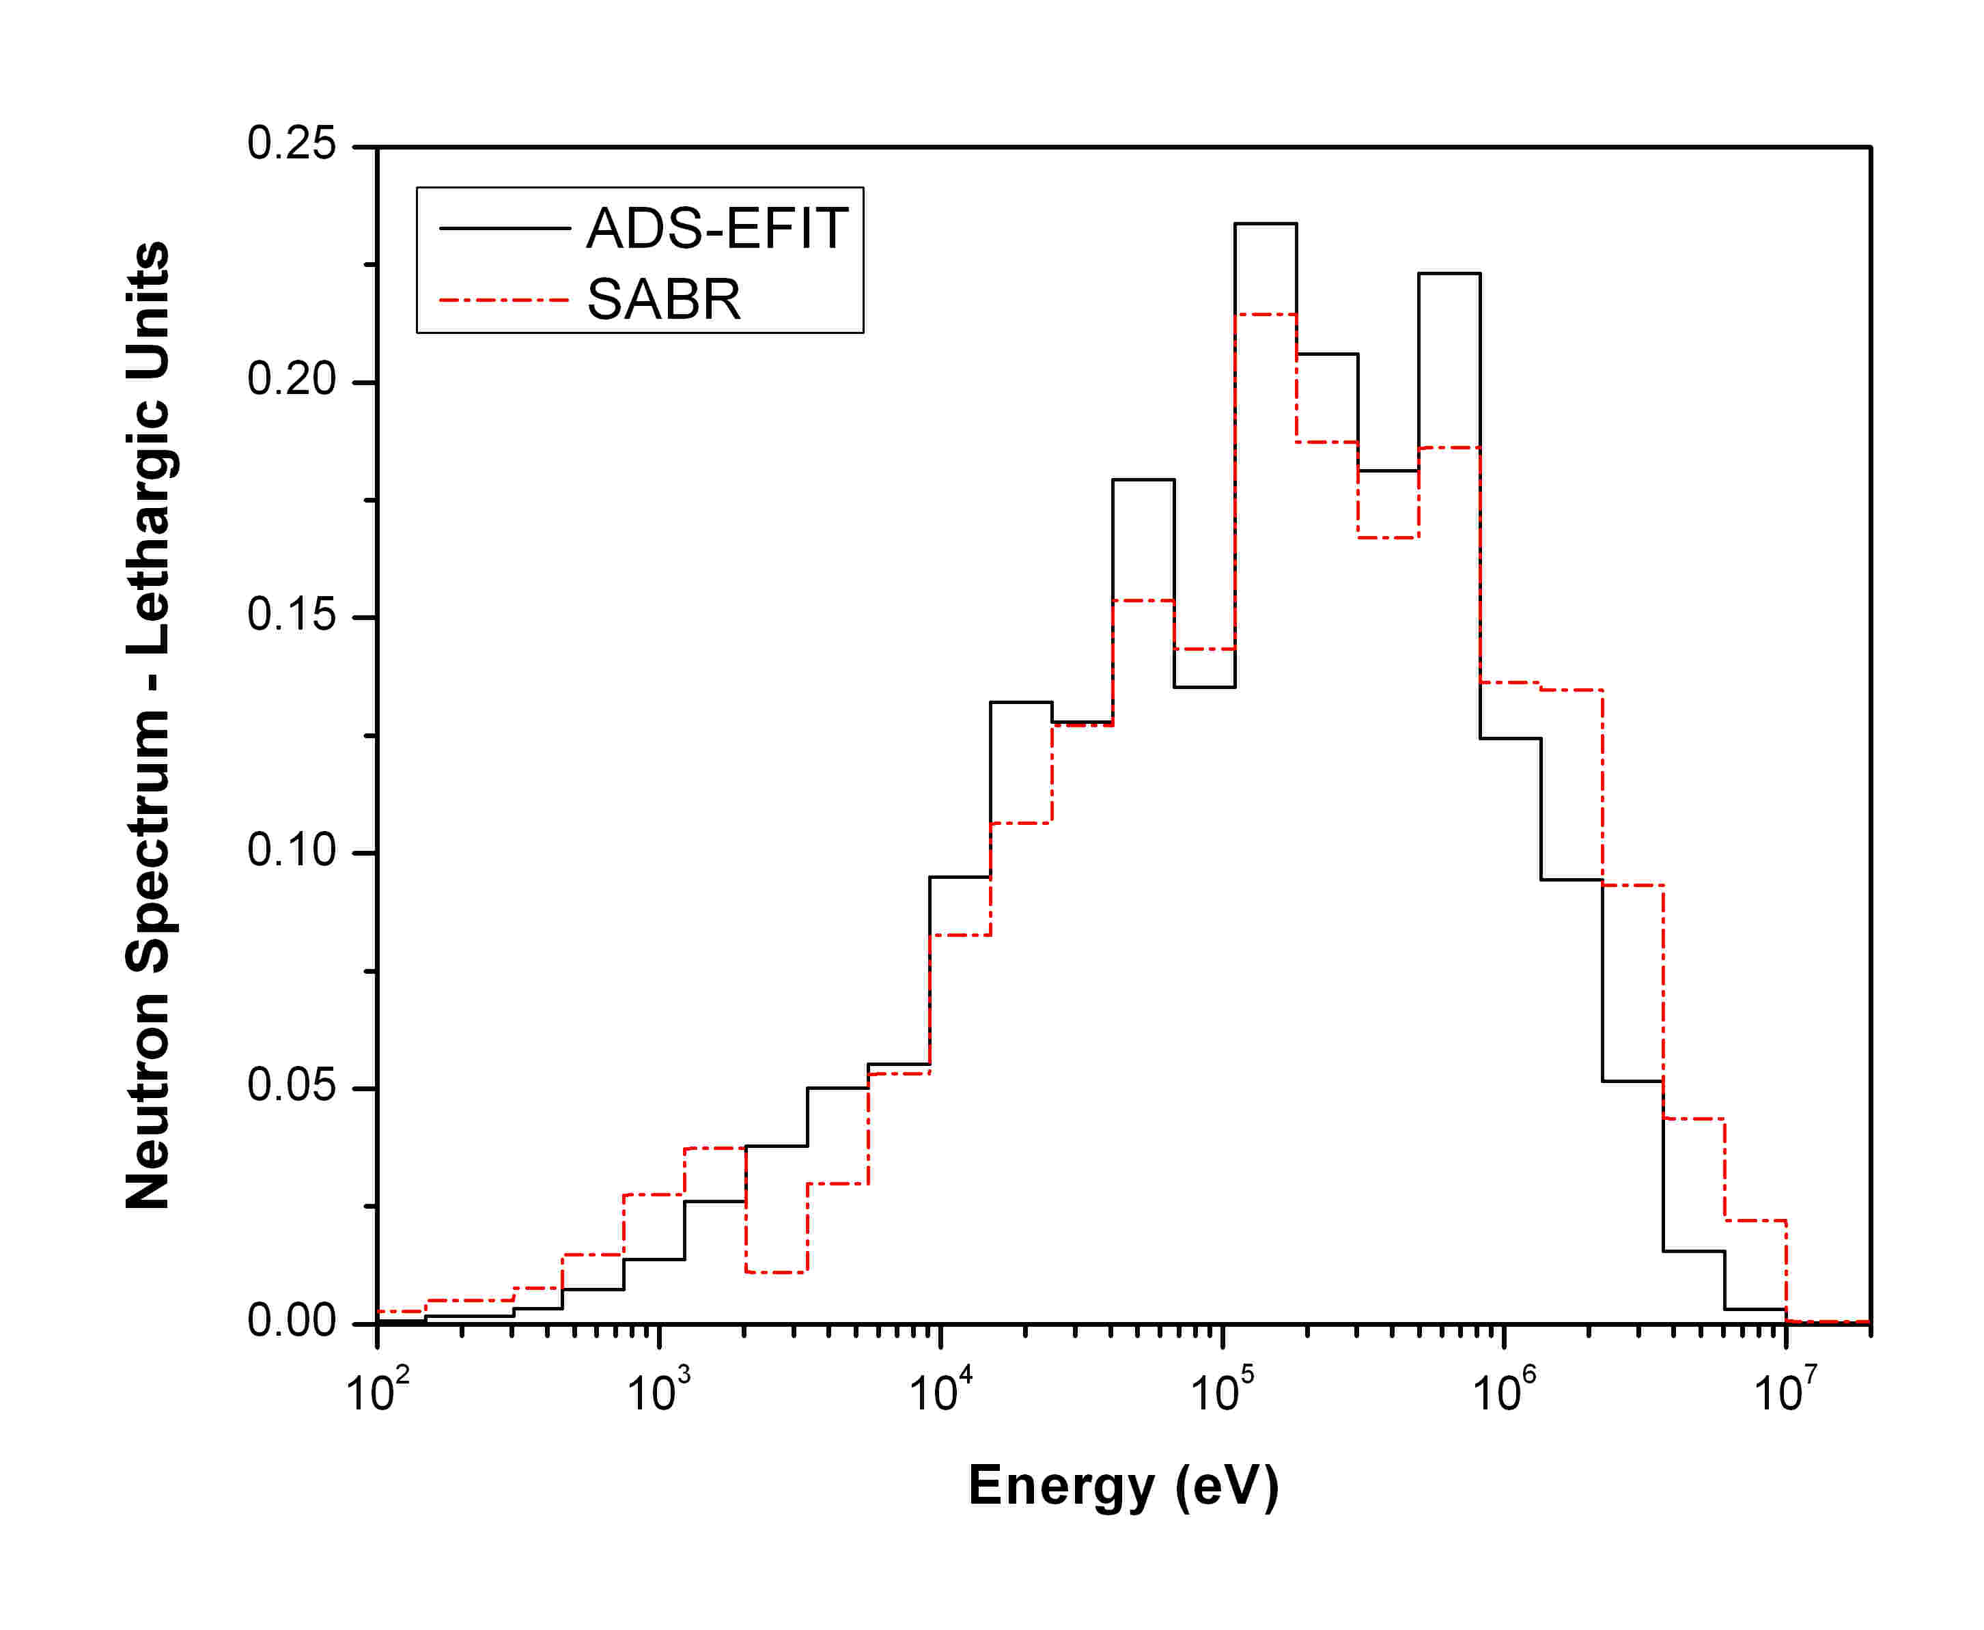
Fig.2. Pu-239 and Am-241 capture cross sections vs. energy comparison between ADS-EFIT and SABR systems
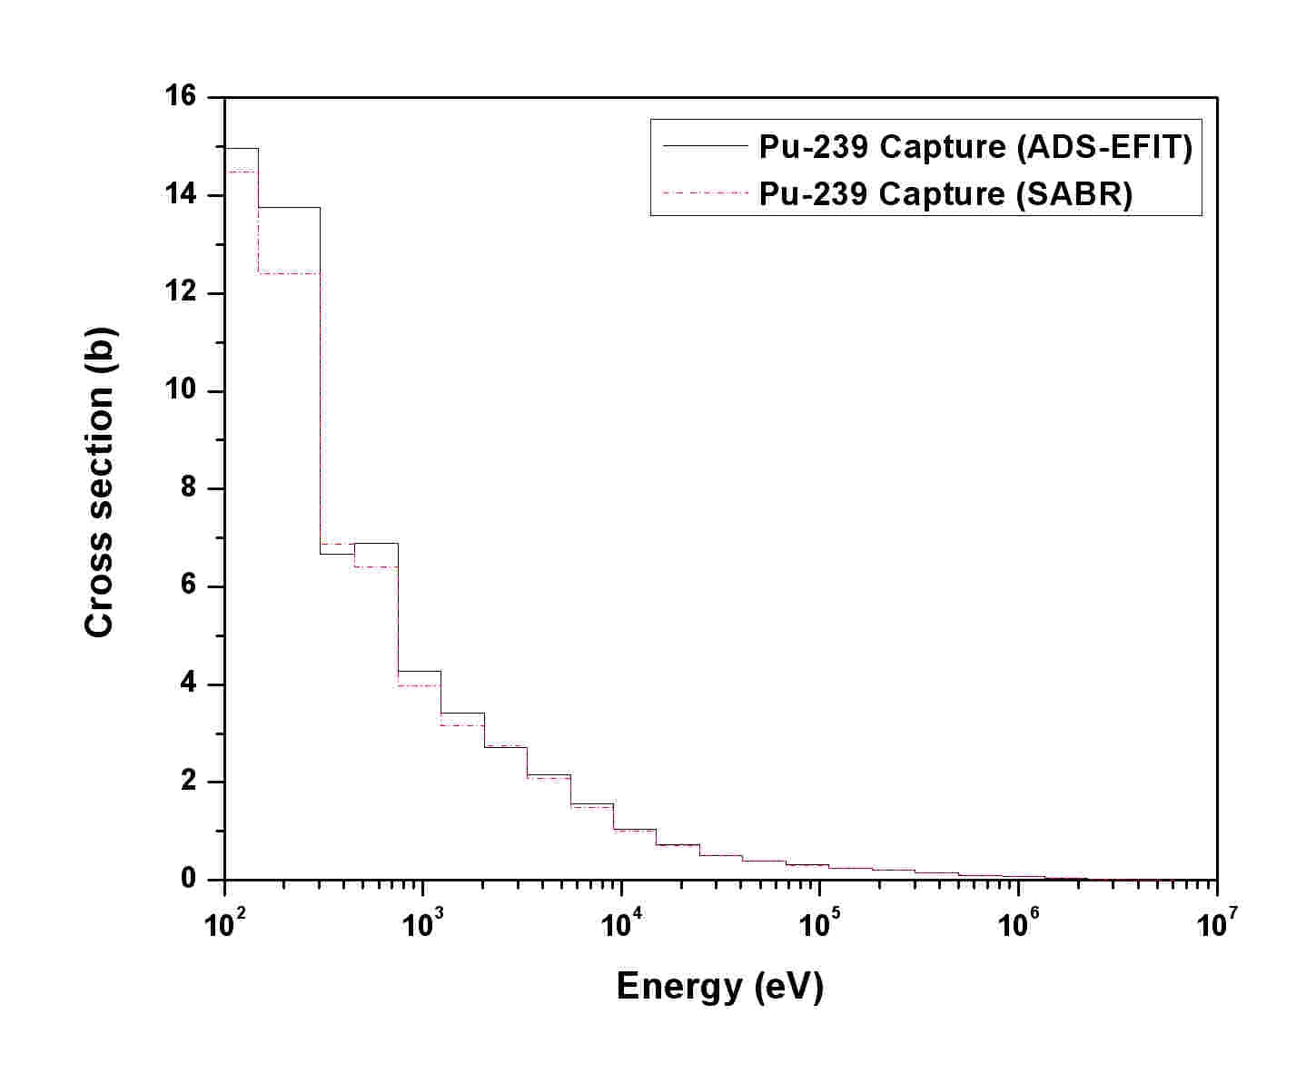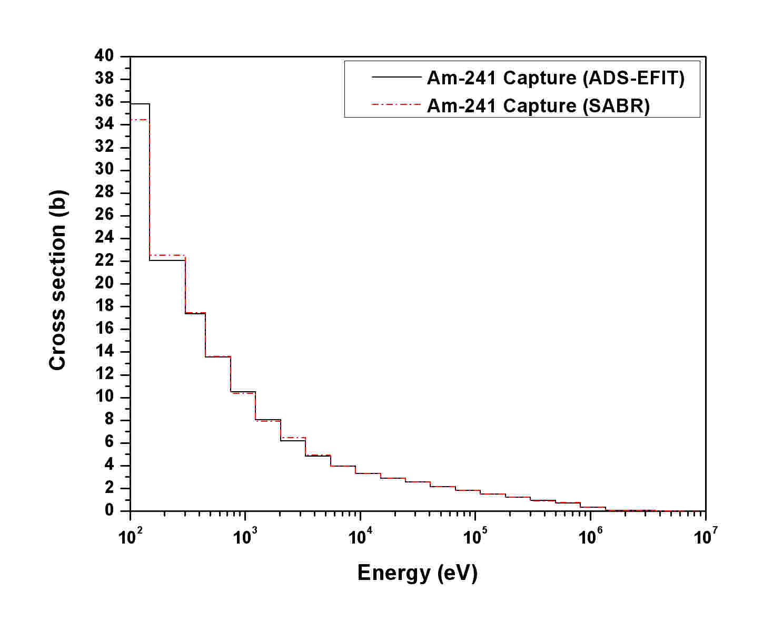

Table 1. Isotopic composition share (wt.%) of spent LWR fuel: 90% of UOX cooled 30 years and 10% of MOX cooled 15 years, both with a burn up rate ~45GWd/tHM (MA/Pu~1.2)
Isotope | Content  (wt.%) | Isotope | Content  (wt.%)
Np-237 | 2.2 | Am-241 | 41.0
Pu-236 | ~0 | Am-242 | 0.1
Pu-238 | 1.7 | Am-243 | 8.7
Pu-239 | 21.2 | Cm-242 | ~0
Pu-240 | 15.6 | Cm-243 | ~0
Pu-241 | 1.8 | Cm-244 | 1.6
Pu-242 | 5.4 | Cm-245 | 0.6

Table 2. Main parameters of the fast reactor burners (SABR and ADS-EFIT)
Parameter | ADS-EFIT | SABR
Fuel type | (TRU)O₂-MgO | (TRU)O₂-MgO
MA/Pu | ~1.2 | ~1.2
Conversion ratio | 0.0 | 0.0
Cycle length (EFPD) | 365 | 700
Average fuel irradiation time (EFPD) | 1095 | 2800
Av. TRU content (%) | 51 | 45
Power (GW_{th}) | 0.384 | 3.0
Average discharge burnup (MWd/kg) | 78 | 184
Reactivity Loss (%Δρ) | ~0.0 | -60.1
Efficiency | 40 % | 40 %
TRU transmutation rate (kg/yr) | 141 | 1097
MA transmutation rate (kg/yr) | 135 | 1050
Pu transmutation rate (kg/yr) | 7 | 46
Support ratio | 5.4 | 42

Table 3. Spectrum indexes at fuel BOL and EOL in ADS-EFIT and SABR
 |  | $$\frac{σ_{c,\text{Pu}−\text{239}}}{σ_{f,\text{Pu}−\text{239}}}$$ |  | $$\frac{σ_{c,\text{Am}−\text{241}}}{σ_{f,\text{Pu}−\text{239}}}$$ |  | $$\frac{σ_{c,\text{Am}−\text{243}}}{σ_{f,\text{Pu}−\text{239}}}$$
ADS-EFIT | BOL | 0.303 | 0.625 | 1.066 | 0.155 | 0.939
ADS-EFIT | EOL | 0.320 | 0.612 | 1.099 | 0.147 | 0.974
SABR | BOL | 0.350 | 0.545 | 1.046 | 0.176 | 0.903
SABR | EOL | 0.400 | 0.477 | 1.109 | 0.145 | 0.908

Table 4. TRU consumption (kg/TWh_{th}) of ADS-EFIT and SABR (fuel discharge values)
Isotope | ADS-EFIT (EFPD=1095) | SABR  (EFPD=2800)
Pu²³⁸ | 19.3 | 18.2
Pu²³⁹ | -23.2 | -21.9
Pu²⁴⁰ | -1.6 | -2.3
Pu²⁴¹ | 0.1 | 1.2
Pu²⁴² | 3.4 | 3.0
Am²⁴¹ | -45.4 | -41.7
Am^{242M} | 4.5 | 2.6
Am^{242f} | 0.3 | 0.01
Am²⁴³ | -8.4 | -6.4
Np²³⁷ | -1.2 | -1.3
Cm²⁴² | 5.5 | 2.7
Cm²⁴³ | 0.2 | 0.2
Cm²⁴⁴ | 4.8 | 3.6
Cm²⁴⁵ | -0.4 | 0.2
Cm²⁴⁶ | 0.1 | 0.0
Total Pu | -2.0 | -1.8
Total MA | -40 | -40.0
Total | -42 | -41.8

Transmuter type impact on double strata scenario simulation
The selected double strata fuel cycle uses UOX and MOX fueled PWR in the first stratum and inert matrix (CER-CER) fuel (described above) in the subcritical transmuters (ADS-EFIT and SABR). The specification of the simulation scheme corresponds to a European regional scenario study which has already been investigated in the framework of the EU PATEROS project [8]. Spent UOX and MOX fuel, discharged from LWR is reprocessed in order to separate TRU from fission products (FP) (which, together with reprocessing losses, are sent to a geological repository). Reprocessed Pu and MA are recycled in the regional transmuter facilities and blended with TRU separated from their spent fuel (as soon as available) in subsequent cycle passes. The objective is: a) to fully reprocess spent fuel legacy of some European countries (Group A): Belgium, Czech Republic, Germany, Spain, Sweden and Switzerland, in order to eliminate all the TRU stocks, before the end of the present century and b) to store Pu and to stabilize the MA inventory in European countries (Group B) pursuing nuclear energy generation, as it is the case in France, and planning a future deployment of fast reactors.
In an international regional fuel cycle centre ADS-EFIT or, respectively, SABR will be deployed as a common effort shared by countries of Group A and B. The ADS-EFIT and SABR have the mission to use the plutonium of Group A (as needed by the requirement to have a Pu/MA ratio in the fuel close to one, see above) and to transmute the MA originating from two groups; transmuters burn as first choice MA coming from the Group A in order to get rid of them before the end of the century, according to scenario requirements. Plutonium of Group B is mono-recycled in PWR and SF is stored for future use in a fast nuclear fleet. Transportation, economy and proliferation issues were not addressed, as they were beyond the scope of the present work.
Scenario analysis main results and discussion
The top level goal of the scenario analyses is to eliminate spent fuel legacy in some European countries (Group A) that do not envisage a further development of nuclear energy (or even planning to phase-out) before the end of the current century. The second goal is to stabilize the MA inventory originating from the LWR operation in countries of Group B. Recovered Pu from the legacy SF inventory of Group A is used together with MA for fresh fuel fabrication to be loaded into fast transmuters.
All calculations were performed with COSI6 code (ver. 5.1.4) [18]. A simplified scenario mass flow scheme is presented in Fig. 2.
For the transmutation task ADS-EFIT and SABR transmuters were simulated in the frame of the same hypothesis and assumptions, and with the same initial and boundary conditions. Transmuters will be deployed in a regional centre, and in both cases, regional fuel cycle (FC) facilities such as a reprocessing and fuel fabrication plant for innovative fast reactor fuel, spent fuel interim storage, and perhaps even a potential common repository were considered.
The annual reprocessing capacities required to manage the fuel supply are detailed in Table 5. Regional reprocessing facilities begin to operate in 2030, while transmuters (both ADS-EFIT and SABR) start of operation is assumed to be in 2045. The legacy SF mass of Group A amounts to about 18,000 tonnes in total. The estimated German LWR UOX and MOX spent fuel inventory [19] in 2022 ca. 9,500 tonnes are added to the SF stock due to presently planned Germany final phase-out date, thus increasing the inventory up to ca. 27,500 tonnes. The total spent fuel mass of Group A will be reprocessed by 2072 (see Fig. 3), the separated plutonium in partly stored in a separated storage and partly used to feed the MA/Pu mixture to be burned in the fast transmuters (SABR or ADS-EFIT), Minor actinides (Np, Am and Cm) are collected in two separate MA stocks for each group of countries.

Fig. 2. Simplified mass flow scheme in the regional scenario: 1st phase: only Gr.A and B are present (till the half of the century); 2nd phase: the regional facility enters into operation; 3rd phase: MA of Gr.A were transmuted (before the end of the century) – only Gr.B and regional facility remain in operation
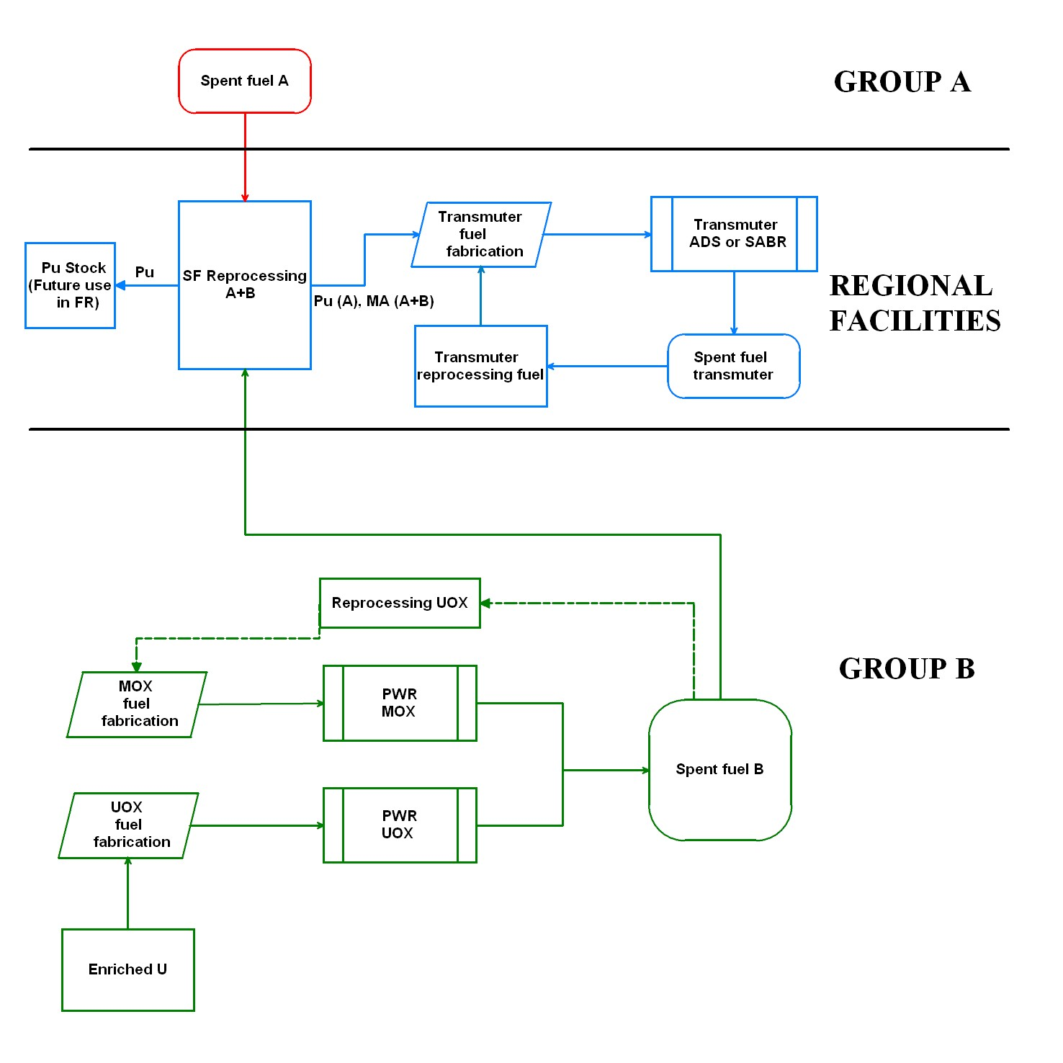

Fig. 3. Group A spent fuel mass vs. time
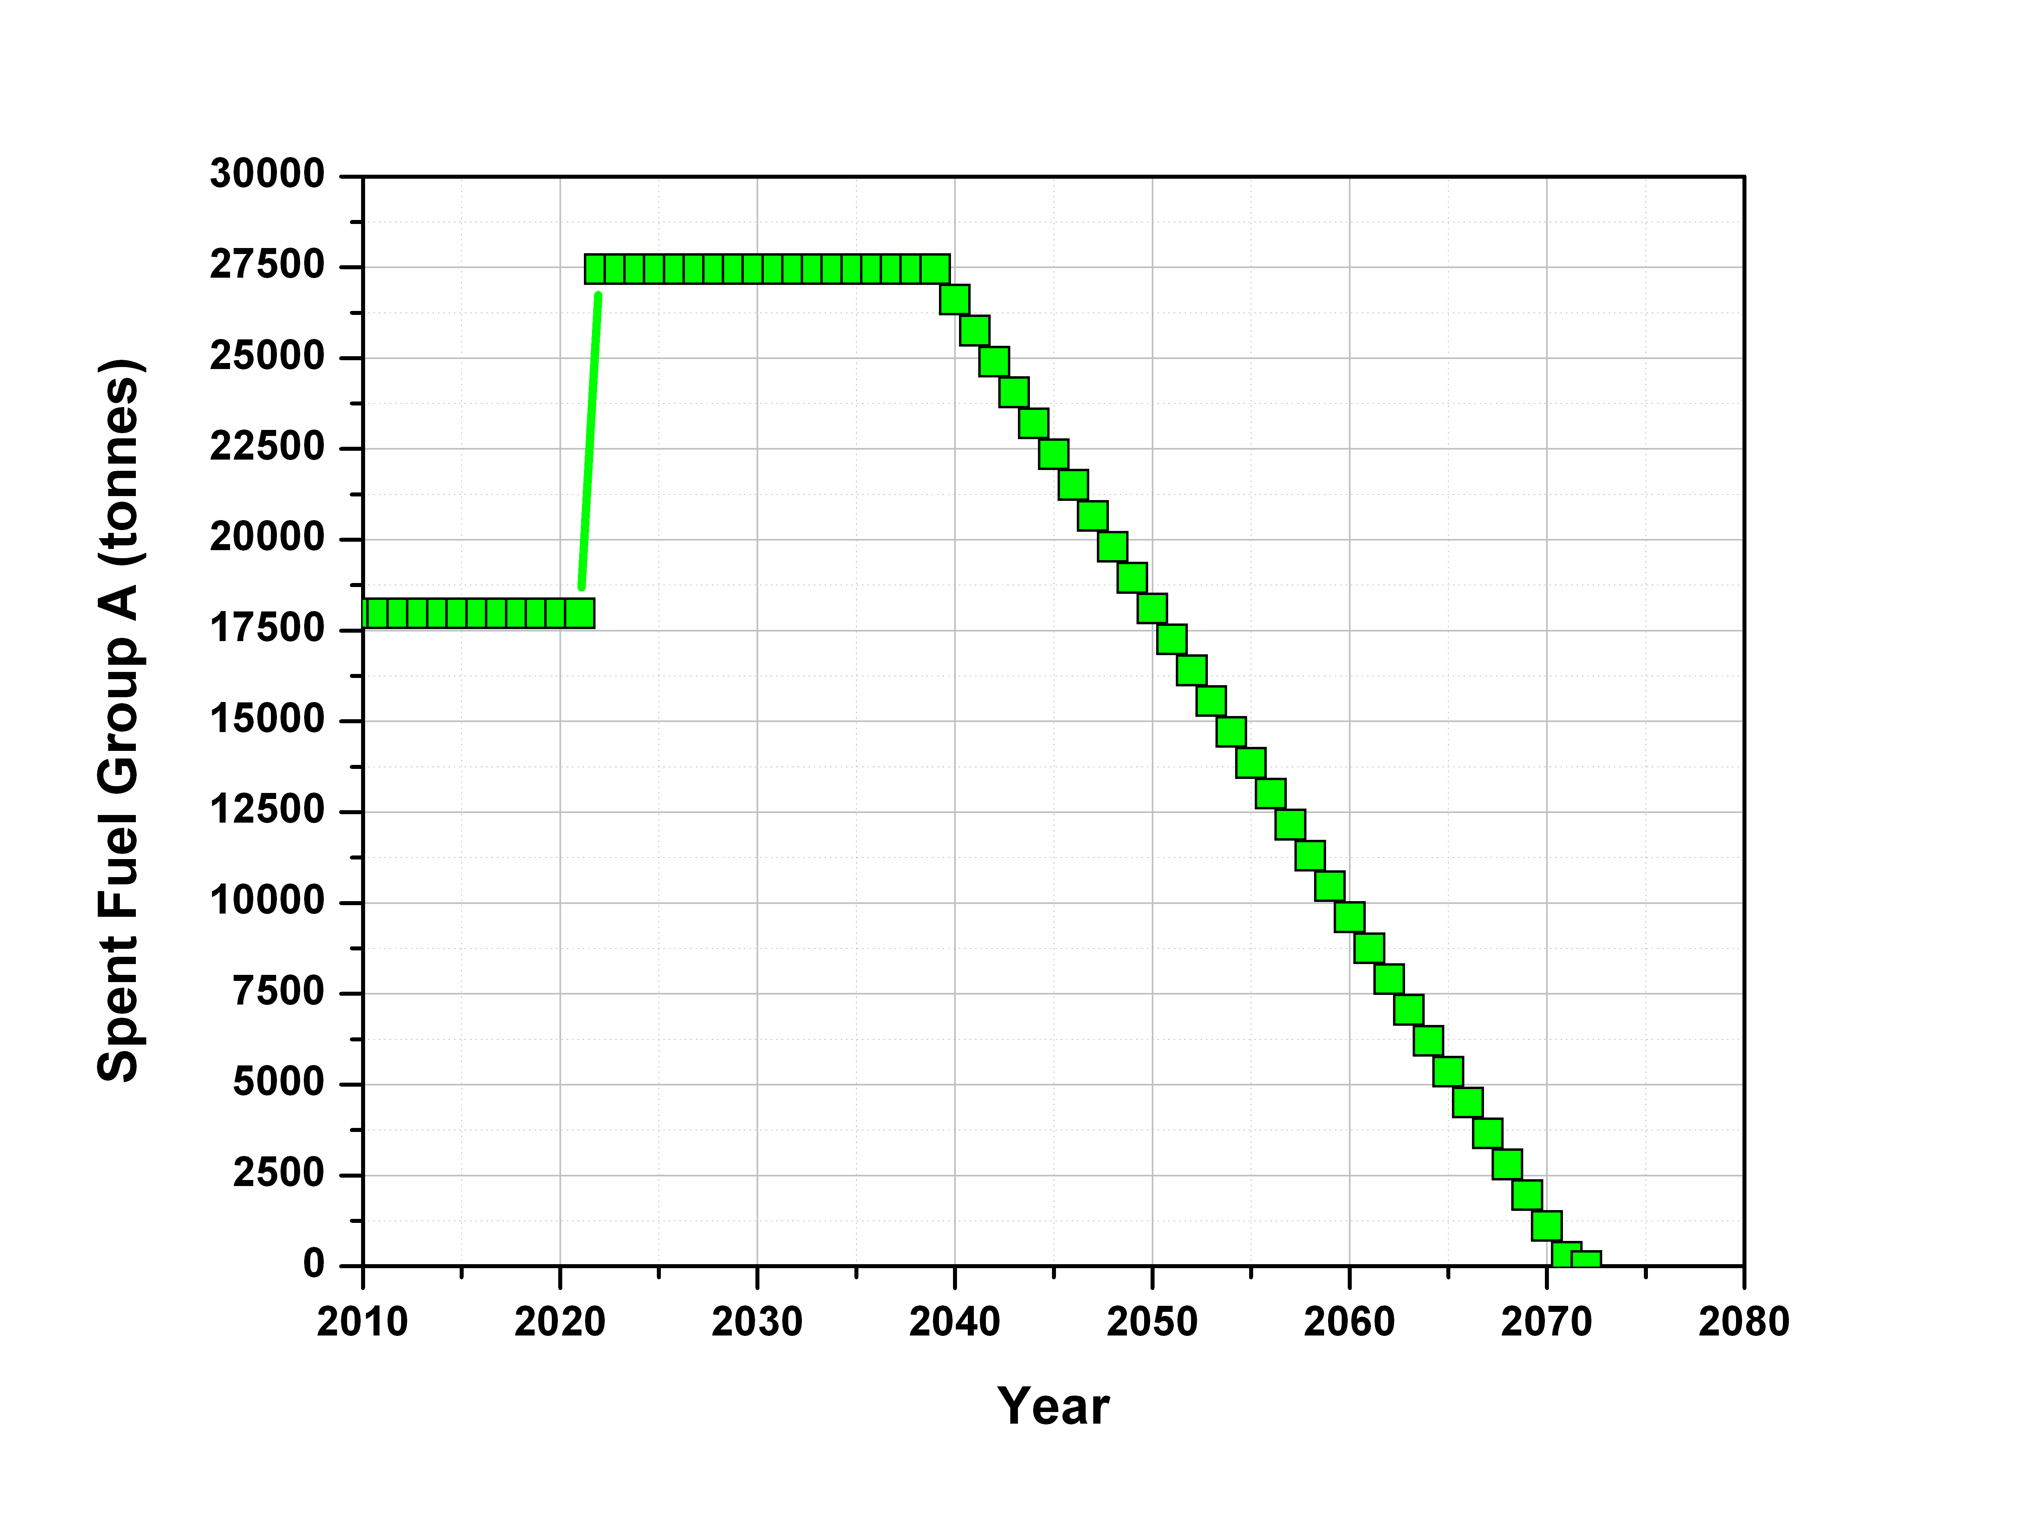
Table 5. Annual capacities (in tonnes) required for fuel supply with start year of operation (in parenthesis)
Annual capacities
(tonnes of Heavy Metal)
 | ADS-EFIT | SABR
Fuel fabrication | 26 (max.) | 27.5 (max.)
SF reprocessing | 26 (2050) | 27.5 (2050)
Reprocessing  Group A -SF | 850 (2040)
Reprocessing  Group B - UOX | 1500 (2010)
Reprocessing  Group B - MOX | 200 (2010)
PWR SF reprocessing (Groups A+B) - total | 2550 (2040)

In general the total Pu mass available, including Pu recovered from the fuel reprocessing of the PWR 60 GWe fleet of Group B, will reach at the end of the century around 900 tonnes. This plutonium inventory is in principle sufficient to allow the transition from a full thermal reactor to a fast reactor fleet. However the aging of Pu (increasing Am-241 content) and thus the time dependent deterioration of its quality (e.g. Pu fissile content) requires further investigation on the basis of advanced modeling.
To facilitate and simplify the comparison it was assumed that both SABR and ADS-EFIT have the same net efficiency of 40%. Scenario analyses were carried out until the end of the next century i.e. 2200, assuming the transmuters energy production curve over the next hundred of years. In COSI6 simulations the transmuter deployment pace was suitably tuned in order to meet the goals of the scenario (Fig. 4).

Fig. 4. Energy production for the two fast transmuter systems
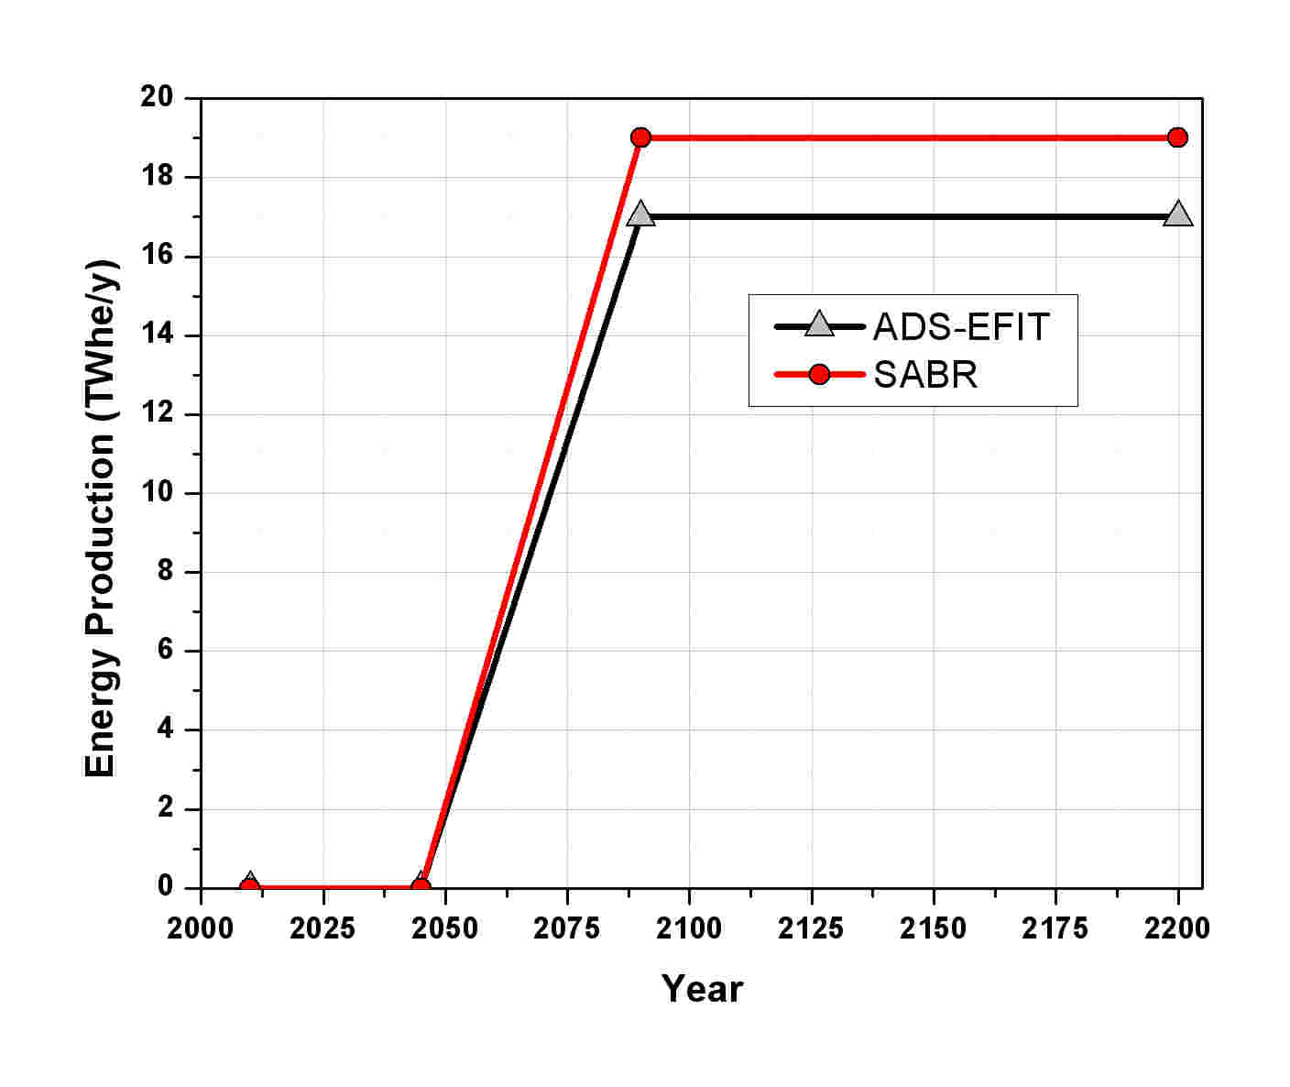
The small difference in energy production between the case with ADS-EFIT and with SABR is related to the better Am consumption rates exhibited by ADS-EFIT (see Table 4), given by the harder SABR spectrum (caused, as discussed above, by different coolants volume fractions). It should be noted moreover that the energy production indicated in the figure above corresponds, respectively, to that one produced by ca. 2 SABR and 15 ADS-EFIT units.
The evolution with time of the content of the MA stocks of Group A and B countries are shown in Figs. 5 and 6 respectively.
The MA stocks of Group A are eliminated ~7-8 years earlier if ADS-EFIT are used, and in both cases the goal is reached before the end of the current century, according to scenario requirements. This result follows from the discussion held above about Am-241 consumption rate differences. As for the MA stocks of Group B, the stabilization will be achieved at approximately the same date (i.e. around 2100). However, the stock stabilizes at a higher value (~140 t) for SABR reactors than for ADS-EFIT (~100 t). This is due to the fact that into ADS-EFIT, the MA of Group B can be loaded some years earlier than it is the case of SABR, as stated above. In fact, in the COSI6 simulation first MA from Group A are completely transmuted, and only after that those from Group B start to be used.
In order to give some preliminary indications of the impact of the adopted P&T strategy, some selected fuel cycle parameters such as the spent fuel heat load, neutron emission at fuel fabrication and radiotoxicity in the repository have been evaluated, and no significant differences have been found between the case with SABR reactors and the case with ADS-EFIT.
The mass of fuel in interim storages is shown in Fig. 7: it can be seen that a higher mass of SF must be disposed off in case of ADS-EFIT (the ratio being roughly equal to that one of transmuters burnup, see Table 2).
The potential benefits of an international transmutation centre implementing P&T strategy are rather independent on the transmuter type.

Fig. 5. MA mass evolution vs. time in the Group A stock
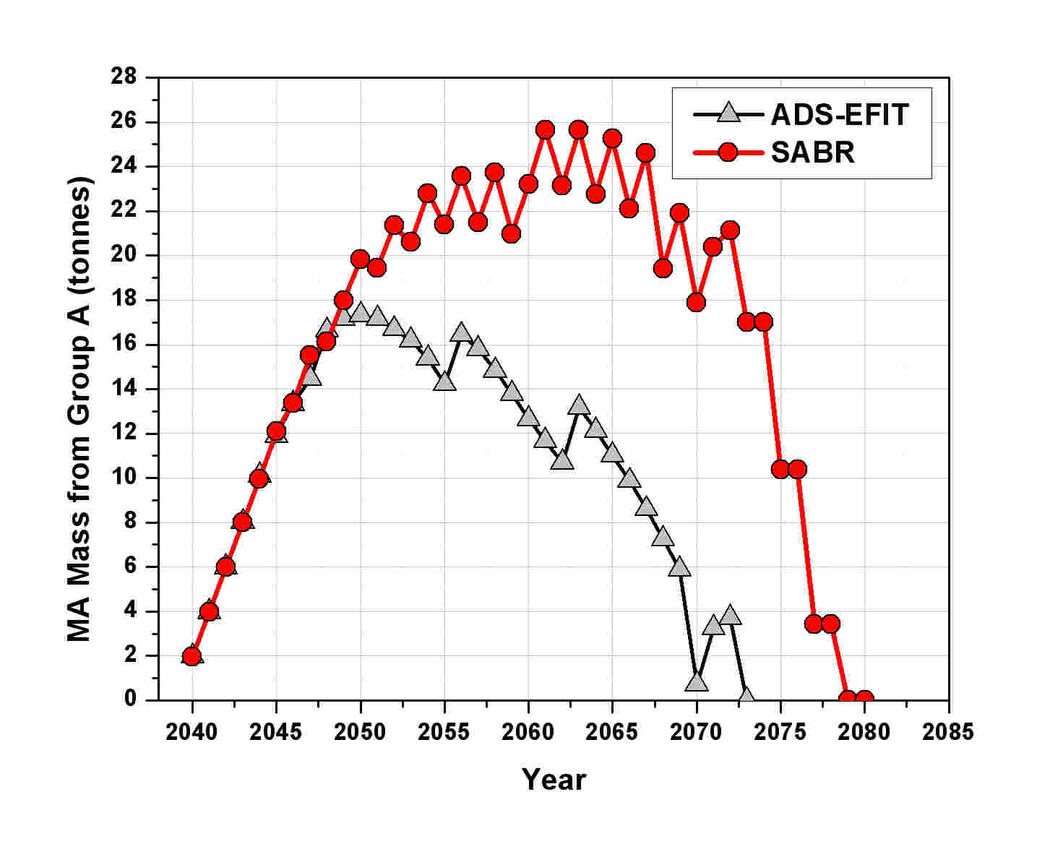
Fig. 6. MA mass evolution vs. time in the Group B stock
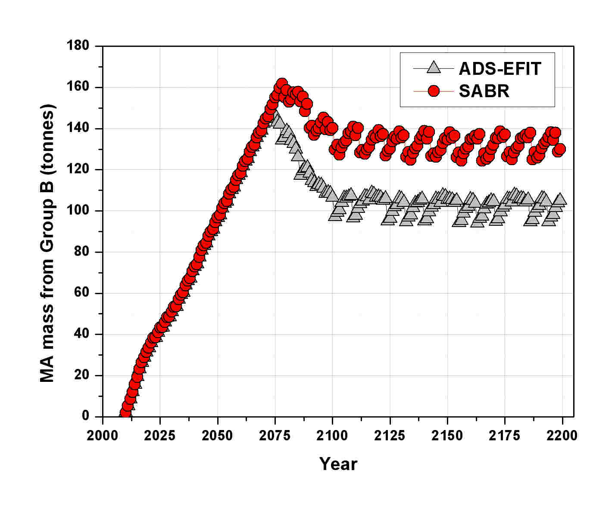

Fig. 7. Masses of transmuter SF in interim storage vs. time
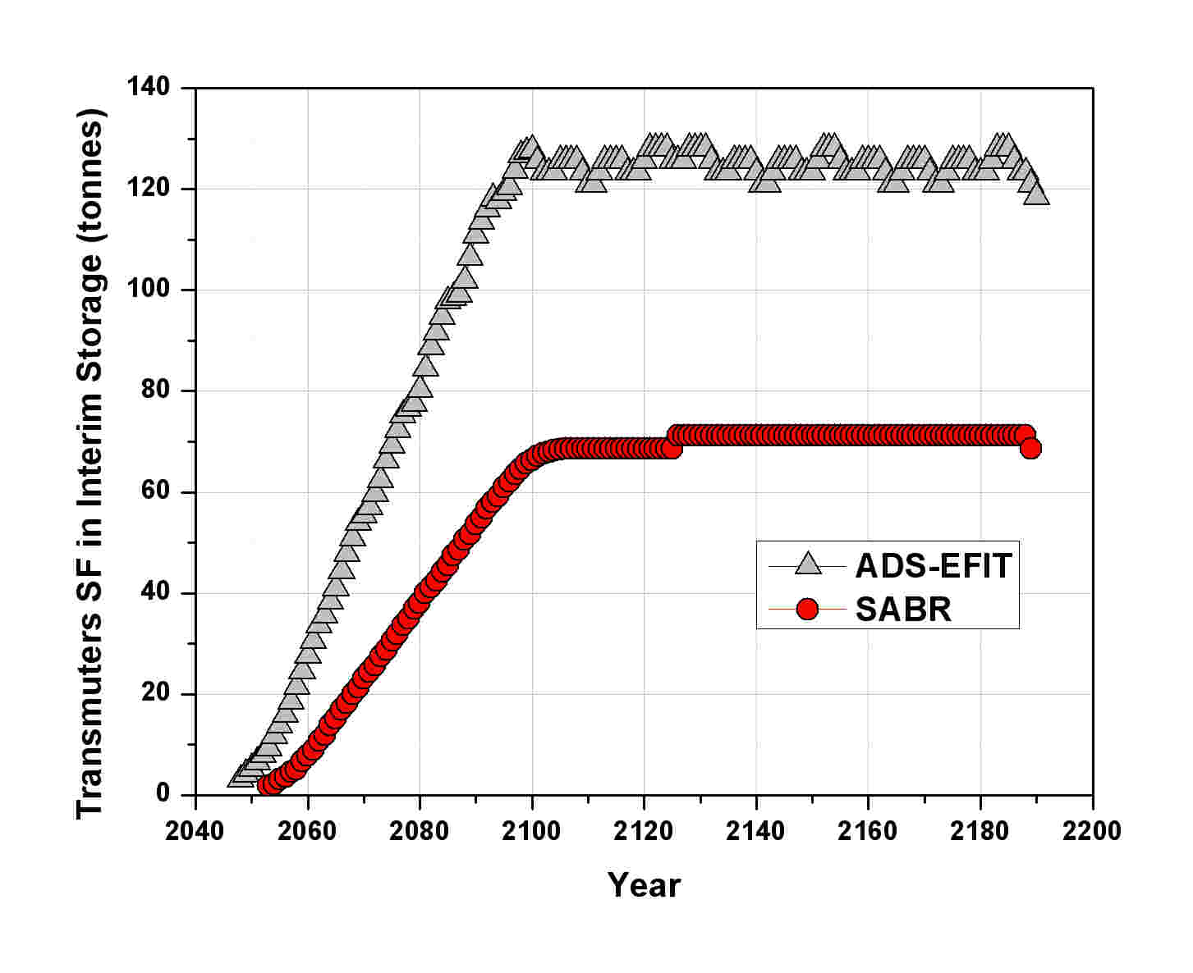
Conclusions
A comparison between an accelerator driven (ADS-EFIT) and a fission-fusion hybrid (SABR) systems was presented in the present paper. The systems were loaded with the same fuel composition, containing roughly 45% Pu and 55% MA. Reactor neutronics analysis proved that due to different layout, coolants nature and in particular to their volume fractions in the cores, a harder spectrum in SABR is observed, causing some minor differences in MA burning rates (especially concerning Am-241) between the two systems.
Both transmuters were used for a regional scenario simulation, the performance of the two systems are rather similar, except for some differences coming from different burning rates.
Both transmuters proved to be, in principle, a valuable help for waste management, reducing the burden on a geological disposal and allowing an easier transition to advanced fuel cycles, since the MA build-up can be controlled and stabilized.
The present paper represents a preliminary study, and further developments are foreseen in the future, in particular extending the comparison to other transmuter systems and exploring in more detail fuel cycle impacts.

References
[1] PRIS (Power Reactor Information System) 2010, http://www.iaea.org/programmes/a2/
[2] Special Eurobarometer 297 “Attitudes towards radioactive waste” – European Commission (June 2008)
[3] Salvatores M., 2005. “Nuclear Fuel Cycle Strategies Including Partitioning and Transmutation”, Nucl. Eng. Des., pp. 235, 805.
[4] Rodriguez C. et alii, 2003 “Deep-Burn: making nuclear waste transmutation practical”, Nuc. Eng. Des. 222, pp.299-317
[5] Ait Abderrahim H. et alii, 2001, “MYRRHA : a multipurpose accelerator driven system for research & development” Nuc . Instr. Met. Phys. Res. 463, pp. 487-494
[6] Taczanowski S. et alii, 1998, “Fusion-driven transmutation of nuclear waste – a misconception or an incentive for promotion of fusion energy?”, Fus. Eng. Des. 41, pp. 455-460
[7] Stacey W.M.. et alii, 2002, “A fusion transmutation of waste reactor”, Fus. Eng. Des. 63-64, pp. 81-86
[8] Salvatores M. et al., 2008. “Fuel Cycle Synergies and Regional Scenarios”, Proc. Int. Conf. 10th IEMPT, Mito, Japan, October 6-10.
[9] OECD Nuclear Energy Agency, 2002. “Accelerator Driven Systems (ADS) and Fast Reactors (FR) in Advanced Nuclear Fuel Cycles”, OECD-NEA Technical Report NEA/3109-ADS, OECD Paris.
[10] OECD Nuclear Energy Agency, 2006. “Advanced Nuclear Fuel Cycles and Radioactive Waste Management”, NEA Report No. 5990, OECD Paris.
[11] Rimpault G. et al., 2002. “The ERANOS code and data system for fast reactor neutronic analyses”, Proc. Int. Conf. PHYSOR02, Seoul, Korea, October 7-10.
[12] OECD Nuclear Energy Agency, 2000. “The JEF-2.2 Nuclear Data Library”, JEFF Report 17, ISBN 92-64-17686-1, OECD Paris.
[13] Takizuka T. et al., 2002. “Design Studies of Lead-Cooled ADS Dedicated to Nuclear Waste Transmutation”, Progress in Nucl. En., Vol. 40, April-May, pp. 505-512.
[14] Artioli C. et al., 2007. “Optimization of the Minor Actinides transmutation in ADS: the European Facility for Industrial Transmutation-EFIT-Pb Concept,” Proc. Int. Conf. ACCAPP'07, Pocatello, USA, July 30 – August 2.
[15] W. M. STACEY, et al., “A TRU-Zr Metal Fuel, Sodium Cooled, Fast Subcritical Advanced Burner Reactor”, Nucl. Technol., 162, 53 (2008).
[16] J. P. Floyd, et al., “Tokamak Neutron Source for a Fast Transmutation Reactor” Fus. Sci. Technol., 52, 727 (2007)
[17] Artioli C. et al., 2008. “Minor actinide transmutation in ADS: the EFIT core design”, Proc. Int. Conf. PHYSOR08, Interlaken, Switzerland, September 14-19.
[18] Boucher L. et al., 2006. “COSI: the complete renewal of the simulation software for the fuel cycle analysis”, Proc. Int. Conf. ICONE 14, Miami, USA, July 17-20.
[19] Schwenk-Ferrero A., Rineiski A., Wiese H.W., Maschek W., 2007. “Validation of KORIGEN Heat Assessment for EFIT Cores”, Proc. Annual Meeting on Nuclear Technology (JK2007), Karlsruhe, May 22-24.

